Project Design Phase-II
Technology Stack (Architecture & Stack)

Date | 21 February 2026
Team ID | LTVIP2026TMIDS77557
Project Name | Calculating Family Expenses using Service Now
Maximum Marks | 4 Marks

Technical Architecture:
The architecture includes:
- User Interface (Web UI, Mobile App)
- Application Logic (Expense Management, Dashboard, Reports, Admin Management, Support)
- Database (MySQL/PostgreSQL)
- Cloud Deployment (AWS/ServiceNow)
- File Storage (Cloud Storage or Local Filesystem)
- External APIs (Email API, Payment API)
- Infrastructure (Cloud Server, Kubernetes)
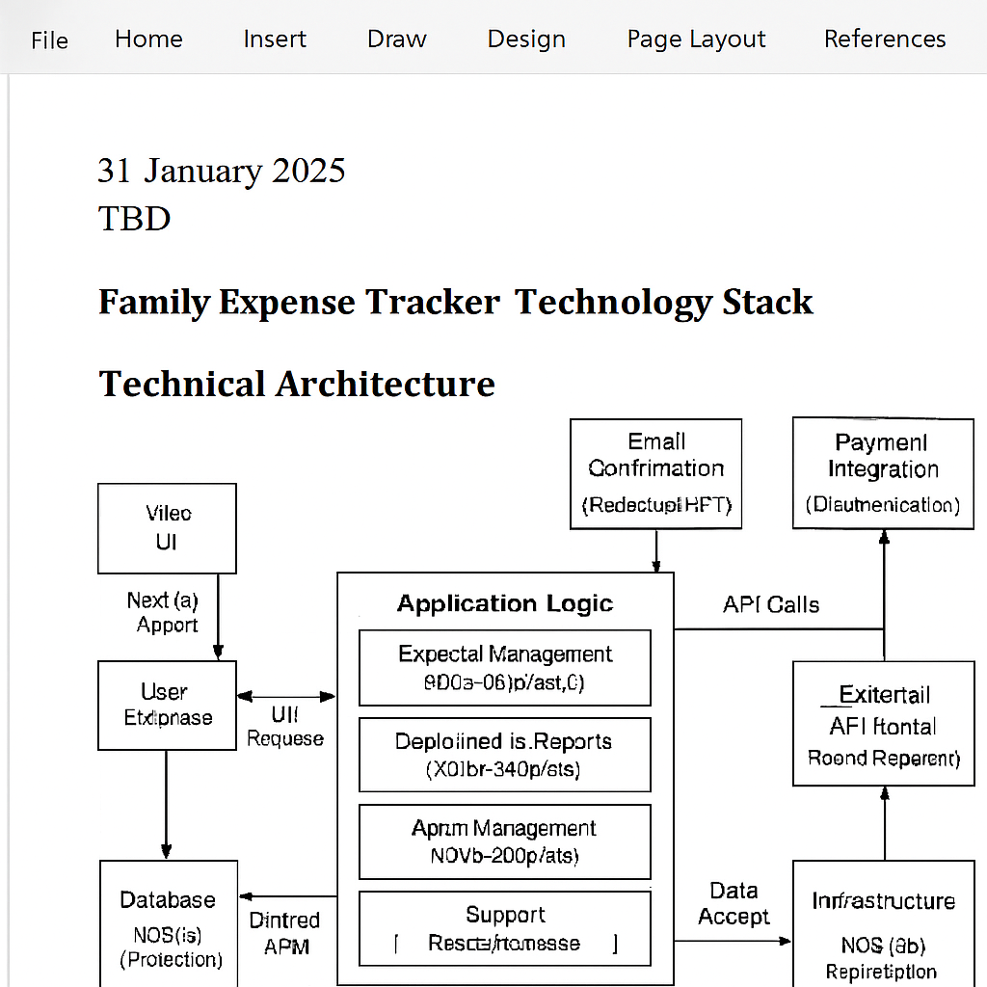

Table-1: Components & Technologies
S.No | Component | Description | Technology
1 | User Interface | Web and Mobile UI for user interaction | HTML, CSS, JavaScript, ReactJS
2 | Application Logic-1 | Expense Management logic | Python/Node.js
3 | Application Logic-2 | Dashboard & Reports logic | Python/Flask, Chart.js
4 | Application Logic-3 | Admin Management & Support logic | Node.js/Express
5 | Database | Store user accounts and expenses | MySQL/PostgreSQL
6 | Cloud Database | Cloud-hosted database service | AWS RDS, ServiceNow DB
7 | File Storage | Store receipts and reports | AWS S3, Local Filesystem
8 | External API-1 | Email confirmation service | SMTP/SendGrid API
9 | External API-2 | Payment integration | Razorpay/Stripe API
10 | Machine Learning Model | Expense categorization | TensorFlow/PyTorch
11 | Infrastructure | Deployment environment | AWS EC2, Kubernetes

Table-2: Application Characteristics
S.No | Characteristics | Description | Technology
1 | Open-Source Frameworks | Frameworks used for UI and backend | ReactJS, Node.js, Flask
2 | Security Implementations | Encryption, authentication, IAM controls | SHA-256, JWT, OAuth2, OWASP
3 | Scalable Architecture | Microservices-based, supports scaling | Kubernetes, Docker
4 | Availability | High availability with load balancers | AWS ELB, Distributed Servers
5 | Performance | Optimized with caching and CDN | Redis, CloudFront

